MENTAL HEALTH AND JUNK FOOD
~SATYAM KUMAR (P7)
21115128
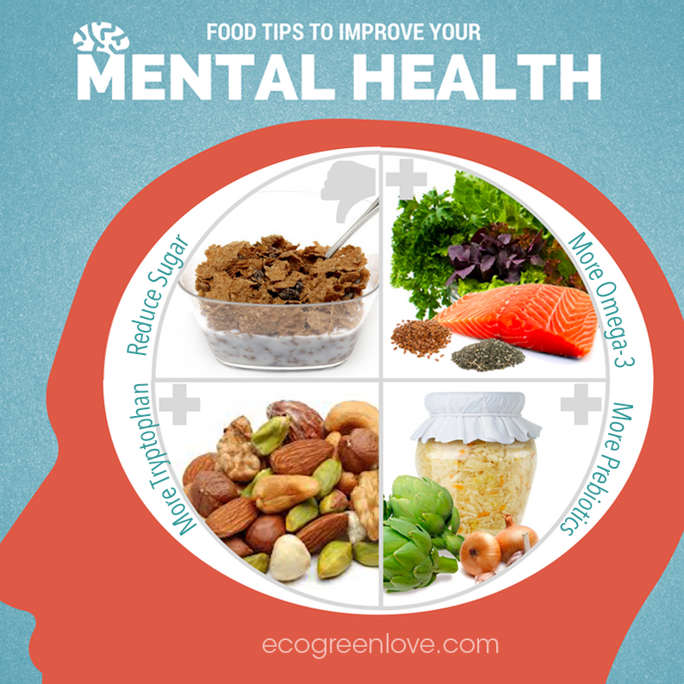
CONTENTS:-
1. INTRODUCTION
2. SCIENCE OF JUNK FOODS
3. EFFECTS OF JUNK FOODS ON THE BRAIN
4. EFFECTS OF JUNK FOODS ON MENTAL HEALTH
5. HOW TO OVERCOME THIS PROBLEM
6. CONCLUSION

INTRODUCTION
A famous quote goes like this - "You are what you eat." The food we eat determines our physical health and our mental health. Eating a balanced diet containing all the essential nutrients can improve our sense of well-being and mood. However, eating a high-calorie diet low in nutrients often harms our mental health, as the name suggests that junk food is junk.

SCIENCE OF JUNK FOODS
Junk food is a type of food high in calories from sugar and fat, low in fiber, protein, vitamins, minerals, or another essential nutrient, also known as HFSS Food (high fat, salt, and sugar). Accurate definitions vary in purpose and timing. Some high-protein foods, such as lean meats, can be considered unhealthy. Most junk food is highly digestible, spiking blood sugar levels and increasing harmful cholesterol levels. People use an unhealthy diet to describe foods low in nutrients and high in fat, sugar, and salt, which your body can easily absorb. Sheets of potatoes, sweets, and cold drinks are often considered junk food. As we all know, proteins, fats, carbs, vitamins, and minerals help release several hormones, which unhealthy foods do not provide. As we eat junk food, brain neurons release extra dopamine, which gives us a sense of well-being. When it is released, dopamine enters the receptors in the brain, and when the balance is correct, it feels pleasure. This is one reason why people, after trying unhealthy foods, fall into the trap of eating too many times.

EFFECTS OF JUNK FOODS ON THE BRAIN
1. An unhealthy diet can make you high. The brain has a reward system that makes us want to engage in behaviors that we find enjoyable, like eating tasty food; after consuming junk foods, the reward circuit activated by our brain releases dopamine. Our brains can be overwhelmed by the excitement from these beneficial foods, and as a result, the brain adapts and activates many dopamine receptors. This means that a large amount of junk food is needed to get the same “kick,” which makes us eat more, in the same way an addict develops drug tolerance. Thus, our brains work hard to find and crave nutritious food, making us dream and crave sugary and fatty foods.

2. Unhealthy food catches our attention and makes it rash. We soon learn that these fatty, sugary foods are delicious and that our attention is drawn to what we see. We need a central nervous system, the prefrontal cortex, to resist temptation. This area does not mature until we turn 20, so young people sometimes act hastily. Recent research has also shown that sugary drinks at an early age can alter brain development. We found young rats to eat sugary water and tested it in decision-making activities as adults. We have found that young people who consume sugar find it challenging to follow the rules as adults. Combine this with the fact that the young brain is not functioning correctly, and it is not surprising that many young people are starting to gain weight.

3. Unhealthy food can burn your brain. Unhealthy foods are highly refined and contain high levels of sugar and fat, in addition to many natural foods. In the same way, as you eat uncomfortable food, it can blow your mouth. Junk food can cause similar reactions in the brain. This is called neuroinflammation, and it initiates a continuous series of events that lead to further inflammation that can damage brain cells. Australian researchers have recently shown that just five days of eating sugary drinks, cakes, and cookies caused an increase in inflammation levels in the hippocampus. People who damage their hippocampus feel hungry all the time. The hippocampus is essential in receiving signaling signals from the gut, so eating junk food can create a vicious cycle of damage to neurons in the hippocampus, and damage can cause people to overeat.

4. Unhealthy food reduces the brain's ability to learn. The hippocampus is the center of brain memory, and researchers have found that people who eat a lot of junk food are less active than those who eat healthier foods in simple memory tests. Our experiences are stored as memories, which form in the brain through connections between neurons that are constantly regenerated by responses to the dynamic environment in which we live. The term neuroplasticity can describe this process. Junk food has been shown to reduce neuroplasticity, essential for building new memories and learning new things quickly.

5. Junk food reduces the production of new neurons. The birth of new neurons occurs throughout life in the hippocampus. These new neurons have higher levels of neuroplasticity, which means that they are made more efficient by natural events and are essential for building new memories. Decreases in the number of new neurons have been linked to mental disorders, which includes depression, which brings us back to the idea of ​​making a living, i.e. junk food can make us happy when we are sad, so we eat too much, which makes us feel bad.

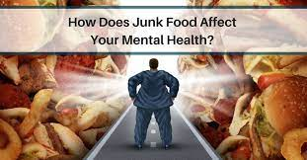
EFFECTS OF JUNK FOODS ON MENTAL HEALTH
Junk foods wreak havoc on the mental health of consumers. Many studies have been done to determine their effect. Experiments on rats have shown the adverse effects of junk food that
may appear similar to humans. Junk foods high in sodium can lead to an increase in headaches and migraines. An unhealthy diet with high carbs can cause acne. Eating junk food may increase your risk of depression. Carbohydrates and sugars in a fast diet can lead to tooth decay. Fried foods are high in trans fats that raise LDL cholesterol levels. Fast food is high in saturated carbohydrates, which increase blood sugar and resists insulin. Due of increased sodium levels our body retains more water, leading to constipation. A Scripps Research Institute study suggested that junk food alters brain function in the same way as the addictive drugs such as cocaine and heroin. After weeks of unrestricted access to junk food, mice's brain centers began to clash, needing more food to enjoy themselves; after the junk food was removed and the healthy food was added, the mice went hungry for two weeks instead of eating the nutritious food. A study in the British Journal of Nutrition found that female rats eating junk food during pregnancy increased their risk of developing unhealthy eating habits in their offspring. Some studies have been done on the effect of sugary foods on emotional health in humans and have suggested that the consumption of junk food can adversely affect energy levels and emotional well-being. In a study published in the European Journal of Clinical Nutrition, the average consumption of 57 food/drinks for 4,000 children aged four and a half was collected by a mother report. At seven, 4,000 children were given a Power Questionnaire (SDQ), with five levels: lack of motivation, behavioral problems, peer problems, emotional symptoms, and socially responsible behavior. The general increase in malnutrition was linked to overweight in 33% of subjects, concluding that seven-year-old malnourished children may be in the upper third of the malnutrition scale. There was no significant correlation between junk food and other rankings. The data was obtained from a surveillance program entitled CASPIAN-IV (Monitoring of Children and Adolescents and Prevention of Non-Communicable Diseases) in a study of school students aged 6 to 18 y in Iran. Students and their parents completed two trustworthy questions from the Persian School Health Survey translated into Persian. The student's questionnaire contained as many questions as possible depression (anxiety, depression, confusion, insomnia, anxiety, anger, and emptiness) and violent behavior (physical violence, victimization, and exploitation). The junk food was sweets, sugary drinks, fast food, and snacks high in salt. In a sample of 13,486 children and adolescents, the frequency of junk food intake was significantly associated with depression. There was a significant link between violent behavior and junk food without sweets, while the link between sugary drinks and victimization was insignificant. Additionally, weight loss results have shown that daily consumption of sugary drinks and snacks dramatically increases the risk of developing depression. Also, a simple salty daily diet was strongly associated with violent behavior, including physical fights (a measure of tension, confidence, victimization, and bullying).
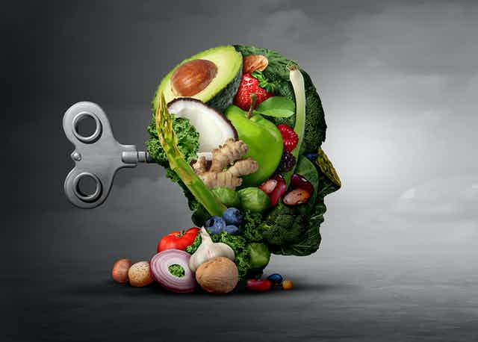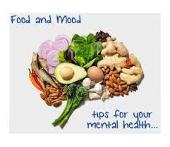
HOW TO OVERCOME THE PROBLEM
To avoid health risks that are bad for you, your diet should be nutritious and varied. Minor changes in your diet can make a huge difference in your life.
- Make half of your plate fruits and vegetables: If your plate has a lot of colors, you are more likely to get the vitamins, minerals, and fiber your body needs, so make sure you choose a variety of red, orange, and green vegetables (like tomatoes, sweet potatoes, and broccoli).
- Make half whole-grain cereals: eating whole grains such as whole-wheat bread will help you avoid high-density cereals that are high in carbohydrates. Look for wheat, brown rice, bulgur, buckwheat, oatmeal, rolled oats, quinoa, or wild rice.
- Switch to low-fat or low-fat milk (1%): The amout of calcium and other nutrients are same in low fat milk and whole milk but fewer calories and less saturated fat.
- Choose a variety of low-protein foods: Lean meat (lean meat) is much better than lean meat. Choose thin cuts of beef, turkey breast chicken breast.
- Compare sodium in food: Use nutritional facts included in food packaging labels to select foods that contain low sodium levels. Choose canned foods with brands that mean low sodium, reduced sodium, or unsalted salt.
- Drink water instead of sugary drinks: You can significantly reduce your calories by drinking water with or without sugar. Soda and energy drinks are higher than extra sugar and calories, so be sure to avoid this. You can add a slice of lemon or lime to your water glass if you want more flavor.
- Eat seafood: Fish and mussels are high in protein, minerals, and omega-3 fatty acids (healthy fats). Try to eat at least eight ounces of seafood a week if you are an adult.
- Reduce solid fats: Sources of solid fats for cakes, pastries, ice cream, and minced meat. Try to avoid these to reduce your intake of saturated fats.
- Drink Water Drinking water before meals may reduce appetite and appetite and help lose weight.
- Eat More Protein An increase in protein can reduce cravings by up to 60% and minimize appetite at night by 50%.
- Stay away from Desire Try to distance yourself from the craving for chewing gum, walking, or bathing.
- Plan Your Diet Planning your meal for the next day or week eliminates self-doubt and uncertainty, both of which can lead to cravings.
- Avoid Extreme Hunger. Hunger is a significant cause of cravings. Avoid extreme hunger by staying ready for healthy snacks.
- Fight Depression: Stress can affect appetite, diet, and weight, especially in women.
- Take Spinach Extract Spinach extract slows down digestion and increases hormones that reduce appetite and cravings.
- Get Enough Sleep Insomnia may interfere with normal digestive hormones, which lead to cravings and the control of unhealthy foods.
- Eat Proper Food Eating the right foods helps prevent hunger and cravings while ensuring that your body gets the nutrients it needs.
- Don't Go To The Supermarket Hungry Eating before going to the store helps reduce the risk of unwanted cravings and hasty shopping.
- Practice Reasonable Eating Conscious eating is about learning to distinguish between desire and actual hunger, helping you choose your answer.

CONCLUSION
We can all take simple steps to change our lifestyle to reduce the impact of unhealthy foods on our brains. Fresh fruits and vegetables have anti-inflammatory antioxidants, including polyphenols and vitamin E. Fatty acids and avocados are good sources of omega-3 fatty acids that improve neurogenesis. Aerobic exercise helps us lose weight and increase neuroplasticity in the brain. So by taking steps to live an active and healthy life, we ​​keep our bodies and our brains in good condition. Finally, I would like to conclude that - With all the information and information provided above, it is clear that junk food is physical and psychological.

REFERENCES:-
- Junk food - Wikipedia
- Five ways junk food changes your brain - RMIT University
- The Bad Effects Of Eating Junk Food | How To Change Your Diet (southgatemedical.com.au)
- Diet and mental health | Mental Health Foundation
- How Food Addiction Works (and What to Do About It) (healthline.com)
- How Long Does It Actually Take to Form a New Habit? (Backed by Science) | HuffPost Life
- 11 Ways to Stop Cravings for Unhealthy Foods and Sugar (healthline.com)

